SEACOLE CLASS SUMMER HALF TERM 2 THEME – What a Wonderful World
Subject | What we will be doing in school… | What you could do at home…
Geography | Our theme will be treasure islands. We will be looking at how volcanic islands are formed and how islands are different from other land masses. We will use maps and globes to name and locate islands, oceans and continents. There will be opportunities to learn about life for children who live on other island countries, such as Jamaica or Japan. We will make 3D maps of islands in small groups. We will also learn about the sea side and hopefully have a field trip to the beach! | Talk about any islands you have visited, read about or seen in films. How are all islands similar? Can you compare two different islands?  There will be opportunities nearer to the end of term for children to research an island of choice.  Look at any maps you have at home and talk about points of interest. When you visit the beach, you could discuss how sand is formed or collect and categorise shells.
English | In English, we will finish our unit on Persuasive letters by writing to a fictional pirate Captain to persuade him why we he should choose us as his crew. We will then write non-fiction texts about life for children on different islands around the world. We will finish with writing action stories based around Mrs Armitage and The Big Wave by Quentin Blake. | Research an island, somewhere in the world. Which continent is it on? Which are the nearest oceans? What is the weather like?  Discuss pirate characters from books and films. What are they like? What skills do they have?
Maths  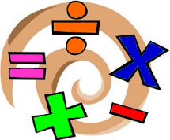 | We will use this half term to consolidate Year 1 and Year 2 key objectives, in line with The National Curriculum. Year 1 children will be developing their understanding of place value and addition and subtraction, so that they are well prepared for the arithmetic component of the Year 2 curriculum in September. Year 2 children will consolidate their understanding of the four operations and use problem solving and reasoning across a range of contexts. | Year 1: Please practise reading and writing numbers to 100, mentally adding and subtracting 1 from given numbers. Regularly practise the end of year 1 counting expectations to count on and back in 2s, 5s and 10s and mental Maths facts such as halves and doubles and number bonds to 10.  Year 2: Keep learning rapid recall of times tables facts (x2, x 10, x 5 x 3) and their related division facts. Practise rapid recall of number bonds to 20 and 100. Tell the time with increasing accuracy.
Computing | We will continue to work on programming, using Bee Bot Apps and Lego Fix The Factory. There will be opportunities to draw islands and design Pirate flags using 2 Simple Software. | What is an algorithm? Do you have any toys or games at home that use algorithms?

Art  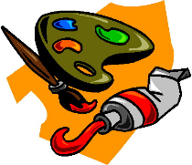 | Miss Keary will be teaching Art during PPA. She will link to our ‘treasure islands’ theme.
PE | We hope to be outside for PE this half term, practising for Sports day and playing ball games. | Watch a variety of ball games together. What are the rules? How do you score points? What skills do different players need?
RE | Our unit on Beliefs continues this half term. We will continue to explore psalms and parables and look at the beliefs of Japanese children through the Tanabata festival. | What beliefs do you have as a family? What do Christians believe? Think about the meanings behind parables and psalms. Have you experienced beliefs or worship in another culture? What is different? What is the same?
PSHE  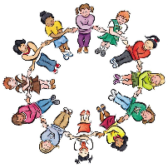 | In PSHE, we will address topical issues through circle times and class assemblies. We will look at how to work as a team and how to be a good friend. | Talk about how to work well as part of a team, even if your best friend is not part of that team. What does good team work look like? How will you know if your team is being successful?
SCIENCE  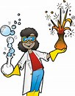 | There will be investigative work, based around our ‘Treasure Islands’ theme. Which materials would be best for making boats? What could you use to build a shelter? We will also be predicting and testing which boats will carry the most cargo. | If you have any small boats we could borrow for our Topic work, please could you send them in? Also, we will be collecting junk modelling items to make boats so please send in any bits from your recycling boxes that might fit the purpose!

