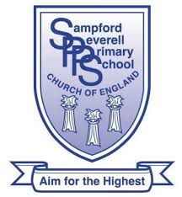
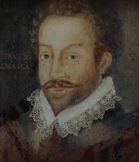
Drake Class
Home Learning Activities

Our main topic until half term is ‘Physical Geography’ which involves the study of natural features of the World – including mountains, volcanoes, rivers and earthquakes.
Here are some suggested activities which the children could complete but any other additional learning at home is welcome so please encourage them to bring in what they have discovered or created.
Children could create a 3D model of a volcano, river or a model explaining how an earthquake happens.
Painting or drawing of natural landmarks would be a great way of showing their artistic skills; we have been looking at using watercolours in class too.
If they would like to use technology to help them discover more facts, they could create a collage of photographs of landmarks or different types of mountains/volcanoes. These could either be printed out or emailed to the school office (sampford@ventrus.org.uk)
In English we have been looking at instructional texts about ‘Survival’ so they could create an instructional text about how to survive a natural disaster or instructions on how to prepare to climb a mountain.
They could also write a story/diary/newspaper/poem/fact card about climbing mountains; surviving a natural disaster or witnessing a disaster in history.
If they show an interest in finding out more about natural features, they could create a PowerPoint or other presentation of their ideas – either using technology or by creating a ‘page project’.
Finally, they could read and take notes of any physical feature they are interested – either one specific mountain for instance or a list of the highest peaks of each continent.

