SEACOLE Summer HALF TERM 1 THEME – ‘Everything Changes’
Subject | What we will be doing in school… | What you could do at home…
English | We are going to begin our half term working around Stuck, by Oliver Jeffers. The outcome will be our own stories about different objects getting stuck.  Our non-fiction text will be persuasive letters, based around our Geographical work on Fair Trade.  We will also be writing recounts, labels and instructions as part of our Science work.  We will also be learning about sentence types (statements, questions, commands and exclamations) and apostrophes of possession and contraction. Correct sentence punctuation will be a key area of focus. We will also continue to work on reading and spelling the common exception words for Years 1 and 2. | Can you identify problems and solutions in other stories that you have shared? Have you read any other books by Oliver Jeffers? How are they different or the same?  Remind children to begin all sentences with capital letters and to end them with full stops, when completing homework. Can your child write questions or exclamations with the right punctuation? Practise spelling the common exception words, as well as reading them.  Please keep up daily reading at home too. Good readers make good writers!
Maths  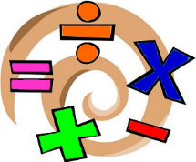 | We will continue to follow the White Rose planning, matched to National Curriculum objectives.  This half term we will be covering measurement (mass, capacity, length and time), statistics and problem solving.  We will also consolidate our understanding of the four operations (+ - ÷ ×) in our Arithmetic and Reasoning work. | Spot the units of measurement for mass, length/height and capacity on packaging and discuss which is bigger, a litre or a millilitre, a gram or a kilogram. Which is taller/longer, a millimetre, centimetre or metre? It would be useful to work on telling the time (o’clock, half past in Year 1 and quarter past, quarter to in Year 2, moving to counting around the clock in 5 minute intervals) Keep working on rapid recall of number bonds, counting patterns and times tables for Year 2s.
Geography | We will be finding out where some of our food comes from, focusing on bananas and chocolate. We will find out about the banana trade and learn about Fair Trade and how to find the Fair Trade logo. | Can you identify fruit and vegetables grown in the UK or other countries? What kind of conditions do different fruit or vegetables need to grow? Can you spot where different fruits and vegetables are grown if you visit a large supermarket? Can you find the Fair Trade logo?
Computing | We will be using Beebots to program and record simple algorithms. We will practise the language of direction: forwards, backwards, left, right, half turn, a quarter turn. | Practise giving directions and using the positional language mentioned. You could download a Beebot app for tablets or I pads at home.

Art  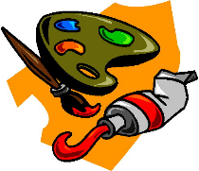 | Miss Keary will be teaching Art during PPA. She will link to our half termly theme on Plants. | Look at botanical drawings or famous paintings depicting plants, such as Van Gogh’s sunflowers, Georgia O Keefe’s flower paintings or Rousseau’s jungle prints.
RE | Our RE unit is Beliefs and Story. We will be looking at the difference between a fact and a belief, explaining our own values, those of the school and our families and friends. We will explore forgiveness through the Parable of The Lost Sheep and interpret the meaning of other parables that we know. | Discuss the values and beliefs that you have at home. What do you, as a family, think makes someone a good person? Share parables and stories with a moral.
PSHE  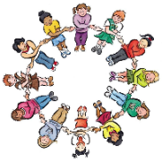 | We will have Circle times to deal with any issues arising in class and regular opportunities for Show and Tell to explore children’s interests. | Talk about how we know when we are safe. What can you do if you don’t feel safe? How can we show respect to each other? How can make sure new people feel welcome in our class?
PE  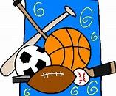 | We are going to be developing our ball skills and team work this half term. We will focus on sending, receiving, throwing, aiming, catching and travelling with balls and bean bags. | Play simple ball games together as a family. Watch ball games such as netball, cricket, football or tennis. How do the players attack or defend? How do players work together as a team?
Science  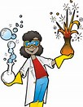 | We will be learning about plants this half term. Our learning question for the unit of work is ‘Are plants important?’ and we will be finding out what plants need to grow, why people need plants, how plants act as ‘green machines’ and whether plants will grow in different conditions and containers. | Explore plants in our local environment. How are they different or the same? Do you grow any food plants?  If you have a garden we could visit (or have a friend or relative with a garden we could visit) please let Ms Phillips know.

