DRAKE CLASS SUMMER TERM 2 TOPIC – Wonderful World
Subject | What we will be doing in school… | What you could do at home…
Science | In this topic we will be identify the properties of different materials. Whether they are: conductor or insulators of heat and electricity; soluble or insoluble; reversible or irreversible when changed. | Do some (safe) scientific experiments at home! See if you can replicate the experiments we will have done in class and explain what happens to people at home. Progress the experiments by looking at different materials – What happens if…
English | In English we are focussing on producing our very best writing ready for the final assessments at the end of the year – including transition pieces | Encourage writing at home. Again, replicate of continue the writing that they are doing in class. See if you can explain how to use advanced punctuation to people at home (such as dashes, semi-colons and colons!)
Maths | We will be looking at statistics – especially line graphs and timetables followed by properties of different shapes. | Look at how graphs and charts are used at home and in the real world to represent data. Collect and represent your own set of date. If you are growing any plants, can you monitor and measure them? Put your measurements into a table of results and then a line graph – remember that time is the key factor when creating a line graph.
Computing | We will be looking at some basic coding apps to create simple operations for ‘sprites’ | Download free apps and software to use at home. If you have a desktop computer or a laptop the ‘Scratch’ from MIT University is an excellent one to play around with.
PE | Premier sports will be delivering some high quality striking and fielding lessons – leading to participating in cricket tournaments as part of the Uffculme cluster. | Play some sports at home! Seek out your local club and get active. Sampford Peverell have a great cricket club or are very welcoming to new members – go along and play!

Art | We will be creating props, costumes and scenery for the production. | Look at set and costume designs from well-known stage productions – especially Matilda and Aladdin from their trips to London. Sketch some ideas down about what props will be needed and what they could look like and what they could be made of.
Music  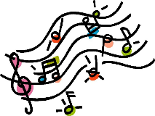 | Our main focus will be singing and preparing for the school production at the end of the year! | Practise those songs! We won’t get going until after SATs but once it is out of the way, it will be all systems go!
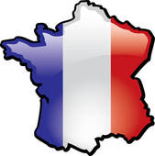  MFL | We will be looking at building a basic understanding of the French language by looking at greetings, school objects and how to ask for things. | Learn some French together! There are lots of great free websites and apps which help learn French.
RE | This term the children will be looking at the ‘The journey of Life and Death’ | Look at asking and answering these BIG questions at home. Do you have any BIG questions of your own? Bring them into school with your thoughts.
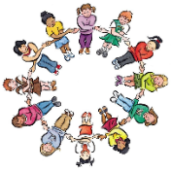  PSHE | Our whole school focus is our Christian Values of: Teamwork, Honesty, Forgiveness, Respect, Trust and Faith so our PSHE sessions will link to these. | Talk about how we can show all of these values in aspects of our lives. Link positive actions to these – ‘You showed great respect towards…today’ or ‘It’s great that I can trust you to do the right thing’

