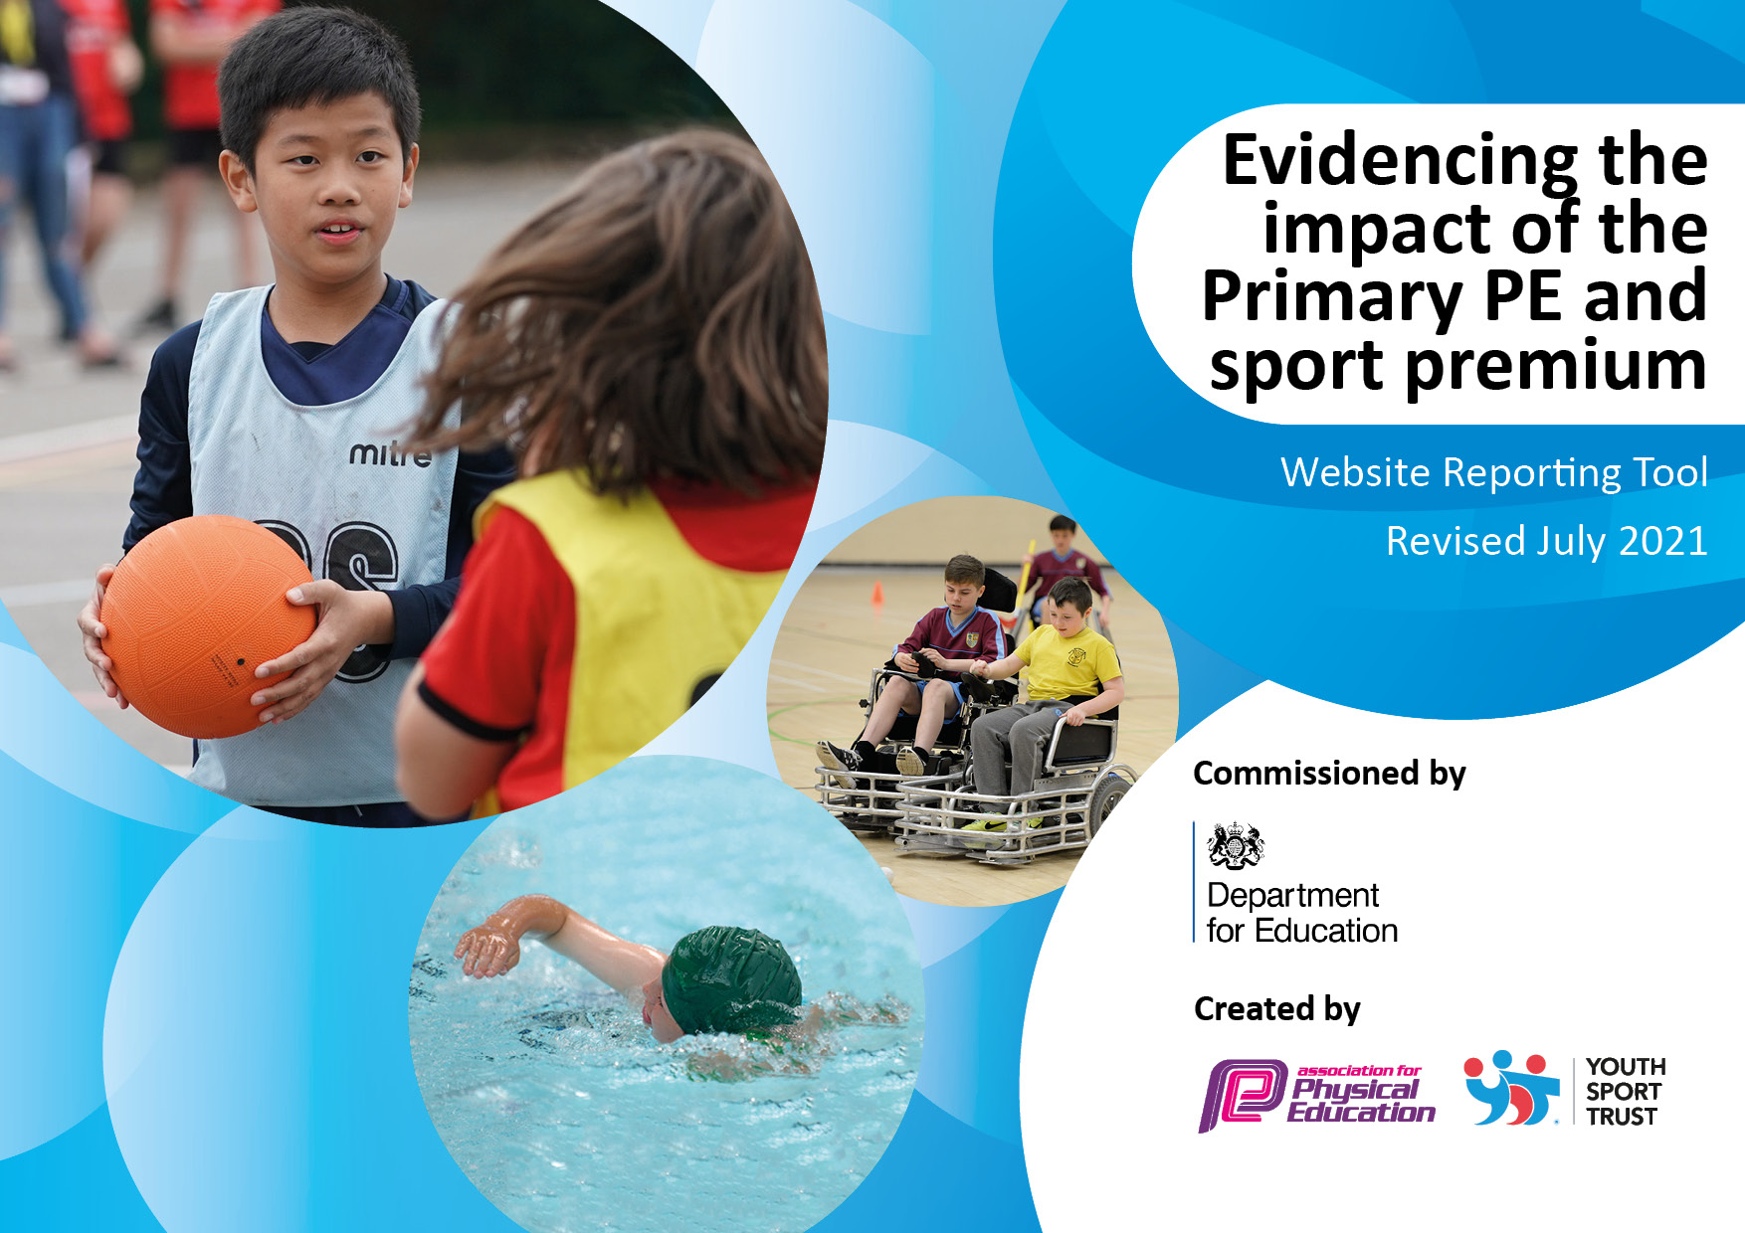
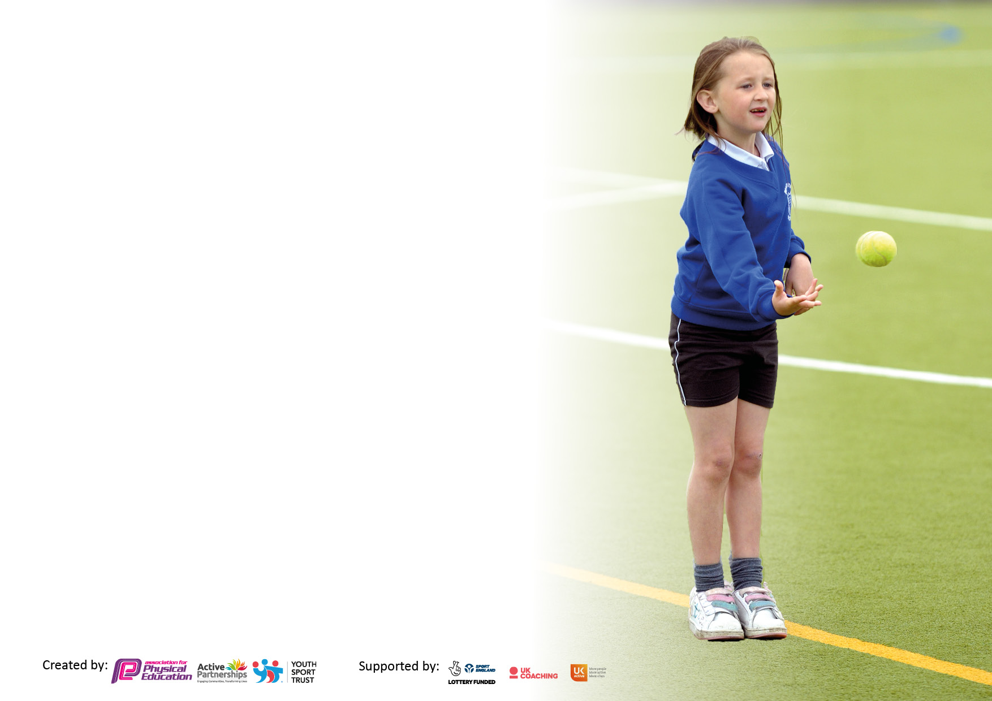

It is important that your grant is used effectively and based on school need. The Education Inspection Framework makes clear there will be a focus on ‘whether leaders and those responsible for governors all understand their respective roles and perform these in a way that enhances the effectiveness of the school’.

Under the Quality of Education Ofsted inspectors consider:
Intent - Curriculum design, coverage and appropriateness
Implementation - Curriculum delivery, Teaching (pedagogy) and Assessment
Impact - Attainment and progress

To assist schools with common transferable language this template has been developed to utilise the same three headings which should make your plans easily transferable between working documents.

Schools must use the funding to make additional and sustainable improvements to the quality of Physical Education, School Sport and Physical Activity (PESSPA) they offer. This means that you should use the Primary PE and sport premium to:

- Develop or add to the PESSPA activities that your school already offer
- Build capacity and capability within the school to ensure that improvements made now will benefit pupils joining the school in future years
- The Primary PE and sport premium should not be used to fund capital spend projects; the school’s budget should fund these.

Pleasevisitgov.ukfortherevisedDfEguidanceincludingthe5keyindicatorsacrosswhichschoolsshoulddemonstrate animprovement.Thisdocumentwillhelpyoutoreviewyourprovisionandtoreportyourspend.DfEencouragesschools to use this template as an effective way of meeting the reporting requirements of the Primary PE and sport premium.

We recommend you start by reflecting on the impact of current provision and reviewing the previous spend.

Schools are required to publish details of how they spend this funding, including any under-spend from 2019/2020, as well as on the impact it has on pupils’ PE and sport participation and attainment. All funding must be spent by 31st July 2022.

We recommend regularly updating the table and publishing it on your website throughout the year. This evidences your ongoing self-evaluation of how you are using the funding to secure maximum, sustainable impact. Final copy must be posted on your website by the end of the academic year and no later than the 31st July 2021. To see an example of how to complete the table please click HERE.
Created by: Supported by:

Details with regard to funding
Please complete the table below.

Total amount carried over from 2019/20 | £0
Total amount allocated for 2020/21 | £16820
How much (if any) do you intend to carry over from this total fund into 2021/22? | £6,677
Total amount allocated for 2021/22 | £16,771
Total amount of funding for 2021/22. To be spent and reported on by 31st July 2022. | £23,448
Swimming Data
Please report on your Swimming Data below.

Meeting national curriculum requirements for swimming and water safety.

N.B. Complete this section to your best ability. For example, you might have practised safe self-rescue techniques on dry land which you can then transfer to the pool when school swimming restarts.
Due to exceptional circumstances priority should be given to ensuring that pupils can perform safe self-rescue even if they do not fully meet the first two requirements of the NC programme of study
What percentage of your current Year 6 cohort swim competently, confidently and proficiently over a distance of at least 25 metres?  N.B. Even though your pupils may swim in another year please report on their attainment on leaving primary school at the end of the summer term 2020.  Please see note above | 89%
What percentage of your current Year 6 cohort use a range of strokes effectively [for example, front crawl, backstroke and breaststroke]?  Please see note above | 89%
What percentage of your current Year 6 cohort perform safe self-rescue in different water-based situations? | 89%
Schools can choose to use the Primary PE and sport premium to provide additional provision for swimming but this must be for activity over and above the national curriculum requirements. Have you used it in this way? | Yes/No

Action Plan and Budget Tracking
Capture your intended annual spend against the 5 key indicators. Clarify the success criteria and evidence of impact that you intend to measure to evaluate for pupils today and for the future.

Academic Year: 2021/22 | Total fund allocated: 23,448 | Date Updated: June 2022
Key indicator 1: The engagement of all pupils in regular physical activity – Chief Medical Officers guidelines recommend that primary school pupils undertake at least 30 minutes of physical activity a day in school |  |  |  | Percentage of total allocation:
 |  |  |  | %
Intent | Implementation |  | Impact | 13200
Your school focus should be clear what you want the pupils to know and be able to do and about  what they need to learn and to  consolidate through practice: | Make sure your actions to achieve are linked to your intentions: | Funding allocated: | Evidence of impact: what do pupils now know and what can they now do? What has changed?: | Sustainability and suggested next steps:
- To increase the attendance at clubs which are promoting Physical Activity. School clubs will be offered to promote physical activity.  1.2 Pupils to have access to equipment suitable for purpose. (Replace broken, tired and worn equipment). Pupils will have suitable equipment for a range of physical activity.  1.4 Pupils to use the minibus so that they can participate in sporting events.  1.5 Pupils will be able to swim 50m which is double to NC target. | Staff to be paid to run after school sports clubs.  Target inactive/less active Pupils to take part in school sporting opportunities.  Purchase correct PE equipment to implement scheme as well as physical playground equipment.  Transport will take Pupils to sporting events.  Pupils who achieve their 25m will continue to be given the opportunity to swim in order to meet our 50m target. | £700  £6500  £1200  £3348 | Pupils attend an active club after school.  Pupils who do not attend clubs outside of school to be encouraged to attend.  Pupils have a range of play equipment to keep them active at playtimes.  Pupils have good quality equipment when accessing PE lessons  Pupils will engage in a range of sports and become more active.  Pupils will enjoy swimming and we understand the health benefits of this activity. | Provide equipment at break times so that the children can practise the skills that they learn at clubs.  Children will be more active at break times.  Audit of PE equipment to be done yearly so that things can be replaced as required so that everything doesn’t need replacing at the same time.  Pupils will enjoy participating in sporting events and so are more likely to be active outside school.  Pupils will be confident swimmers and will choose swimming as a leisure activity out of school.
Key indicator 2: The profile of PESSPA being raised across the school as a tool for whole school improvement |  |  |  | Percentage of total allocation:
 |  |  |  | %
Intent | Implementation |  | Impact
Your school focus should be clear what you want the pupils to know and be able to do and about  what they need to learn and to  consolidate through practice: | Make sure your actions to achieve are linked to your intentions: | Funding allocated: | Evidence of impact: what do pupils now know and what can they now do? What has changed?: | Sustainability and suggested next steps:
2.1 To use GetSet4PE PE to develop Pupils’s physical and health and fitness skills. Pupil’s PE sessions will be high quality and inspire a love of learning in all areas.  2.2 Carefully planned rolling programme for PE to ensure range of sports/skills taught over the primary age range.  2.3 Increase physical activity by using ‘Jump Start Jonny’ to promote daily exercise.  2.4 Increase physical activity by training Play Leaders to deliver a range of timetable activities at lunchtime.  2.5 Use technology to record and assess performances. | Renew subscription for GetSet4PE (3-year discount)  PE coordinator to have release time to monitor range of sports being taught  Renew subscription for ‘Jump Start Jonny’  Play Leaders to run daily sessions for both key stages.  15 iPads with rugged cases to be purchased for KS1 and Reception.  New interactive screen installed in the hall to further develop the teaching and learning of PE. | £7000 | This scheme offers a progressive curriculum which allows Pupils to build on previous learnt knowledge and skill.  Pupil’s will receive a rich and balanced curriculum which they can apply to competitive events and in performances.  Pupils will be more active, healthier and improve gross motor skills  Pupils will have access to a range of activities that encourage them to be active at playtimes.  Pupils will be able to record themselves and others to identify strengths and areas for development in order to improve their technique. | Staff be develop their skills and understanding of PEESPA to better deliver the curriculum.  Pupils will be more active throughout the school day and will be taught different games by the Play Leaders. They will then be able to play these games and show other children how to play.  Pupils will be more confident to use technology to enhance their technique and performance.

Key indicator 3: Increased confidence, knowledge and skills of all staff in teaching PE and sport |  |  |  | Percentage of total allocation:
 |  |  |  | %
Intent | Implementation |  | Impact
Your school focus should be clear | Make sure your actions to | Funding | Evidence of impact: what do | Sustainability and suggested
what you want the pupils to know | achieve are linked to your | allocated: | pupils now know and what | next steps:
and be able to do and about | intentions: |  | can they now do? What has
what they need to learn and to |  |  | changed?:
consolidate through practice:
3.1 Provide further training to the PE coordinator – Level 5 & 6 Combined Primary Physical Education Subject Leadership Qualification.  3.1 Staff to understand best practice when delivering PESSPA. | Contract trained professionals to enhance the CPD offered to staff.  Purchase Safe Practice in PESSPA. | £1700 | Coordinator will be able to better support the development of PE across the school. | PE provision across the school will improve and staff will be upskilled.
Key indicator 4: Broader experience of a range of sports and activities offered to all pupils |  |  |  | Percentage of total allocation:
Intent | Implementation |  | Impact
Your school focus should be clear | Make sure your actions to | Funding | Evidence of impact: what do | Sustainability and suggested
what you want the pupils to know | achieve are linked to your | allocated: | pupils now know and what | next steps:
and be able to do and about | intentions: |  | can they now do? What has
what they need to learn and to |  |  | changed?:
consolidate through practice:
4.1 Wider opportunities for pupils available. | Participation in variety of outdoor activities for Y6 at Grenville eg abseiling, rafting, orienteering, high ropes  Opportunity for the Pupils to take part in local cricket tournament. Pupils try out a new sport to encourage them to partake in wider sporting opportunities in the area.  Sport Week will allow for Pupils to experience different sports a. They will be encouraged to try out new sports and partake in wider sporting opportunities in the local area.  Year 6 pupils will have the opportunity to take part in Exmoor Challenge Training Walks. They will be confident with hiking skills and moorland safety. Year 6 pupils are inspired to walk and lead active lifestyles. | £1000 | Increased participation of a wider variety of sports | Pupils gain experience and enjoyment of different physical activities in the hope that they will continue these in their leisure time.

Key indicator 5: Increased participation in competitive sport |  |  |  | Percentage of total allocation:
 |  |  |  | %
Intent | Implementation |  | Impact
Your school focus should be clear | Make sure your actions to | Funding | Evidence of impact: what do | Sustainability and suggested
what you want the pupils to know | achieve are linked to your | allocated: | pupils now know and what | next steps:
and be able to do and about | intentions: |  | can they now do? What has
what they need to learn and to |  |  | changed?:
consolidate through practice:
5.1 To engage in additional learning community events. All Pupils will have had the opportunity to take part in competitive sport in the local learning community. | School to engage with sporting opportunities set up by the Learning Community Sport and PE group.  Pupils to travel by coach to attend sporting events which compete against local schools. | Contribution to Uffculme School: £1000  £1000 | The Pupils had the opportunity to take part in different sports led by Uffculme secondary school.  All Pupils in KS2 experienced representing the school at a competitive sporting event. | Pupils gain experience of competitive sport and develop their emotional resilience whilst competing.

