DRAKE CLASS SUMMER TERM TOPIC – EVERYTHING CHANGES
Subject | What we will be doing in school… | What you could do at home…
Geography | We are looking at the similarities and differences between countries with a focus on high/mountainous regions | Visit Exmoor or Dartmoor and look at the local landscape. What would living here be like? How are the houses different? How would your lives differ if you lived on the moor? Look at remote mountain regions in the world (potentially Tibetan villages). How do they differ?
English | We will be writing a narrative based on a book called ‘The Tear Thief’ followed by writing some newspaper reports based on school events. | Are there any stories you have at home which talk about emotions? Bring them in to discuss. Think about what it would be like to lose an emotion..what would you do?  Read some local news stories – how are they set out? What vocabulary is used?
Maths | Shape and space will be the main focus for Year 5s whilst the Year6s revise topics in preparation for SATs | Keep working on the areas highlighted in Mathletics. 5-10mins a day is the best way to help to deepen their understanding.
Computing | The children will be using the new iPads to create E-books on our geography topic. | Many of these presentation ‘apps’ are free to download. We will be using ‘Book Creator’ Why not create your own e-book at home using either this app or another piece of software you find. Look at the limitations and preferences of each app/software.
PE | In PE Premier Sports will be running sessions on cricket followed by QUAD kids activities – running, throwing and jumping. | Watch some sport on television and get outside and give it a go! There are many great local clubs to join – especially our village cricket club.

Art | In art the children will be looking at street art to hopefully create a mural in school linked to our geography work. | Look at street art in and around urban landscapes. Is it art? Is it thoughtful? Does it improve the area?
Music  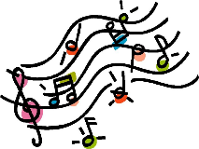 | Our main focus will be singing and preparing for the school production at the end of the year! | Practise those songs! We won’t get going until after SATs but once it is out of the way, it will be all systems go!
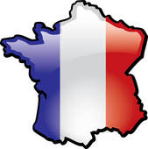  MFL | We will be looking at building a basic understanding of the French language by looking at greetings, school objects and how to ask for things. | Learn some French together! There are lots of great free websites and apps which help learn French.
RE | This term the children will be looking at the ‘The journey of Life and Death’ | Look at asking and answering these BIG questions at home. Do you have any BIG questions of your own? Bring them into school with your thoughts.
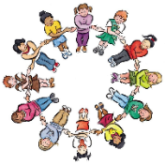  PSHE | Our whole school focus is our Christian Values of: Teamwork, Honesty, Forgiveness, Respect, Trust and Faith so our PSHE sessions will link to these. | Talk about how we can show all of these values in aspects of our lives. Link positive actions to these – ‘You showed great respect towards…today’ or ‘It’s great that I can trust you to do the right thing’

