SPRING HALF TERM 1 THEME – ‘Through The Keyhole’
Subject | What we will be doing in school… | What you could do at home…
English | We will be writing explanation texts about The Great Fire of London. We will also write recounts or diary entries as if we had witnessed the fire. We will continue to work hard on using our phonic knowledge to blend and segment words in our reading and spelling.  We will move onto Traditional Tales toward the end of the half term. | Ask your child to explain what London was like at the time of The Great Fire. Can he/she use the conjunctions and, so, but or because to link ideas in a sentence? Can your child explain how the fire started, how long it lasted and how people fought the fire?  Please continue to practise the spelling and reading of the Common Exception, or tricky words for Years 1 and 2. Please also listen to your child read at home at least three times a week.
Maths  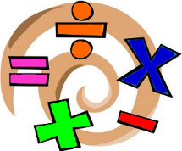 | We will begin by looking at multiplication and division. We will practise counting on and back in 2s, 5s and 10s, moving on to looking at odd and even numbers, halving, doubling and solving calculations using multiplication and division. We will draw pictures and solve and invent Maths stories to show our understanding of key concepts. We will continue to have weekly Arithmetic sessions, in line with the 2014 National Curriculum requirements, solving +, -, x, ÷. We will look at measurement and money. | Practise counting patterns and begin to learn the 10 and 2 times tables by heart, with their related division facts. Read numbers when you are out and about and discuss whether they are odd or even. Use the language of Maths in practical contexts, to share items or double and halve items with other family members. Identify coins and combine coins to make amounts. Can you make the same amount with different coins?
History  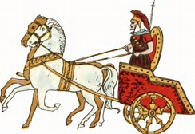 | We will be investigating The Great Fire of London and how it started, why the fire spread so rapidly and how it was stopped. We will learn more about the life of ordinary people in 1666 and how Samuel Pepys was a key witness to the events of the fire. We will also learn a bit more about what London was like at the time of the Fire. | Research the Great Fire online with your child. What can you find out? Can you find information about London before and after the fire? Visit the house that moved in Exeter as it is a local example of a house from a similar era.
Computing | We will play ‘The Great Fire of London game’ and use resources from The Museum of London website. We will explore Fire paintings using Paint Software. We will promote Safer Internet Day. | Can use child friendly search engines to research the Great Fire with your child?

Art  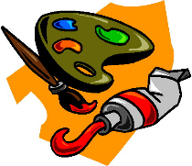 | Miss Keary will be teaching Art during PPA. Children will explore a fire theme through paint and collage. They will also make Art work connected to shape. | Can you research paintings of The Great Fire of London?
RE | Our RE unit is about belonging. Which groups do we belong to? How do Christians show they belong to the Church? | Discuss groups you and your child are part of. How do you show you belong to these groups or communities? Do you have any special family traditions? Which ceremonies or services have you attended at a church? (E.g. Weddings, Christenings, Baptisms)
PSHE  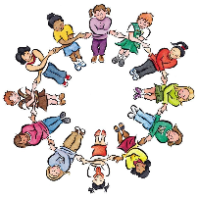 | We will have Circle times to deal with any issues arising in class and regular opportunities for Show and Tell to explore children’s interests. | Talk about how to be a good friend. What does friendship look like? How can we include others in our friendship circles?
PE | We will be exploring The Great Fire of London through dance and movement. Every afternoon there will be active play, with equipment such as hoops, balls and skipping ropes available. | Watch some contemporary dance together. How do the dancers tell stories? How do they work together or individually?
SCIENCE  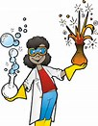 | We will be learning about materials and their properties. We will think about why particular materials are chosen for different purposes and explain why some materials would not be a good choice. We will begin to learn about how water can change state, from liquid to solid or gas by freezing or boiling and how it can change back. | Identify materials around the house. Can you think of adjectives (describing words)? Talk about silly materials, e.g. What would happen if a window was made of chocolate or a chair was made of glass?

