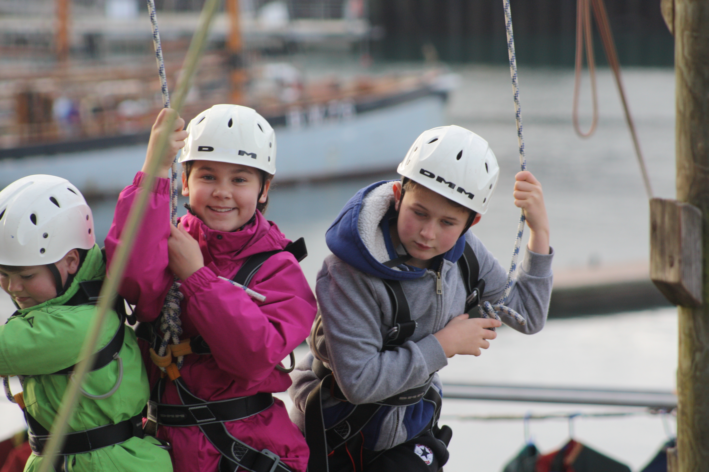
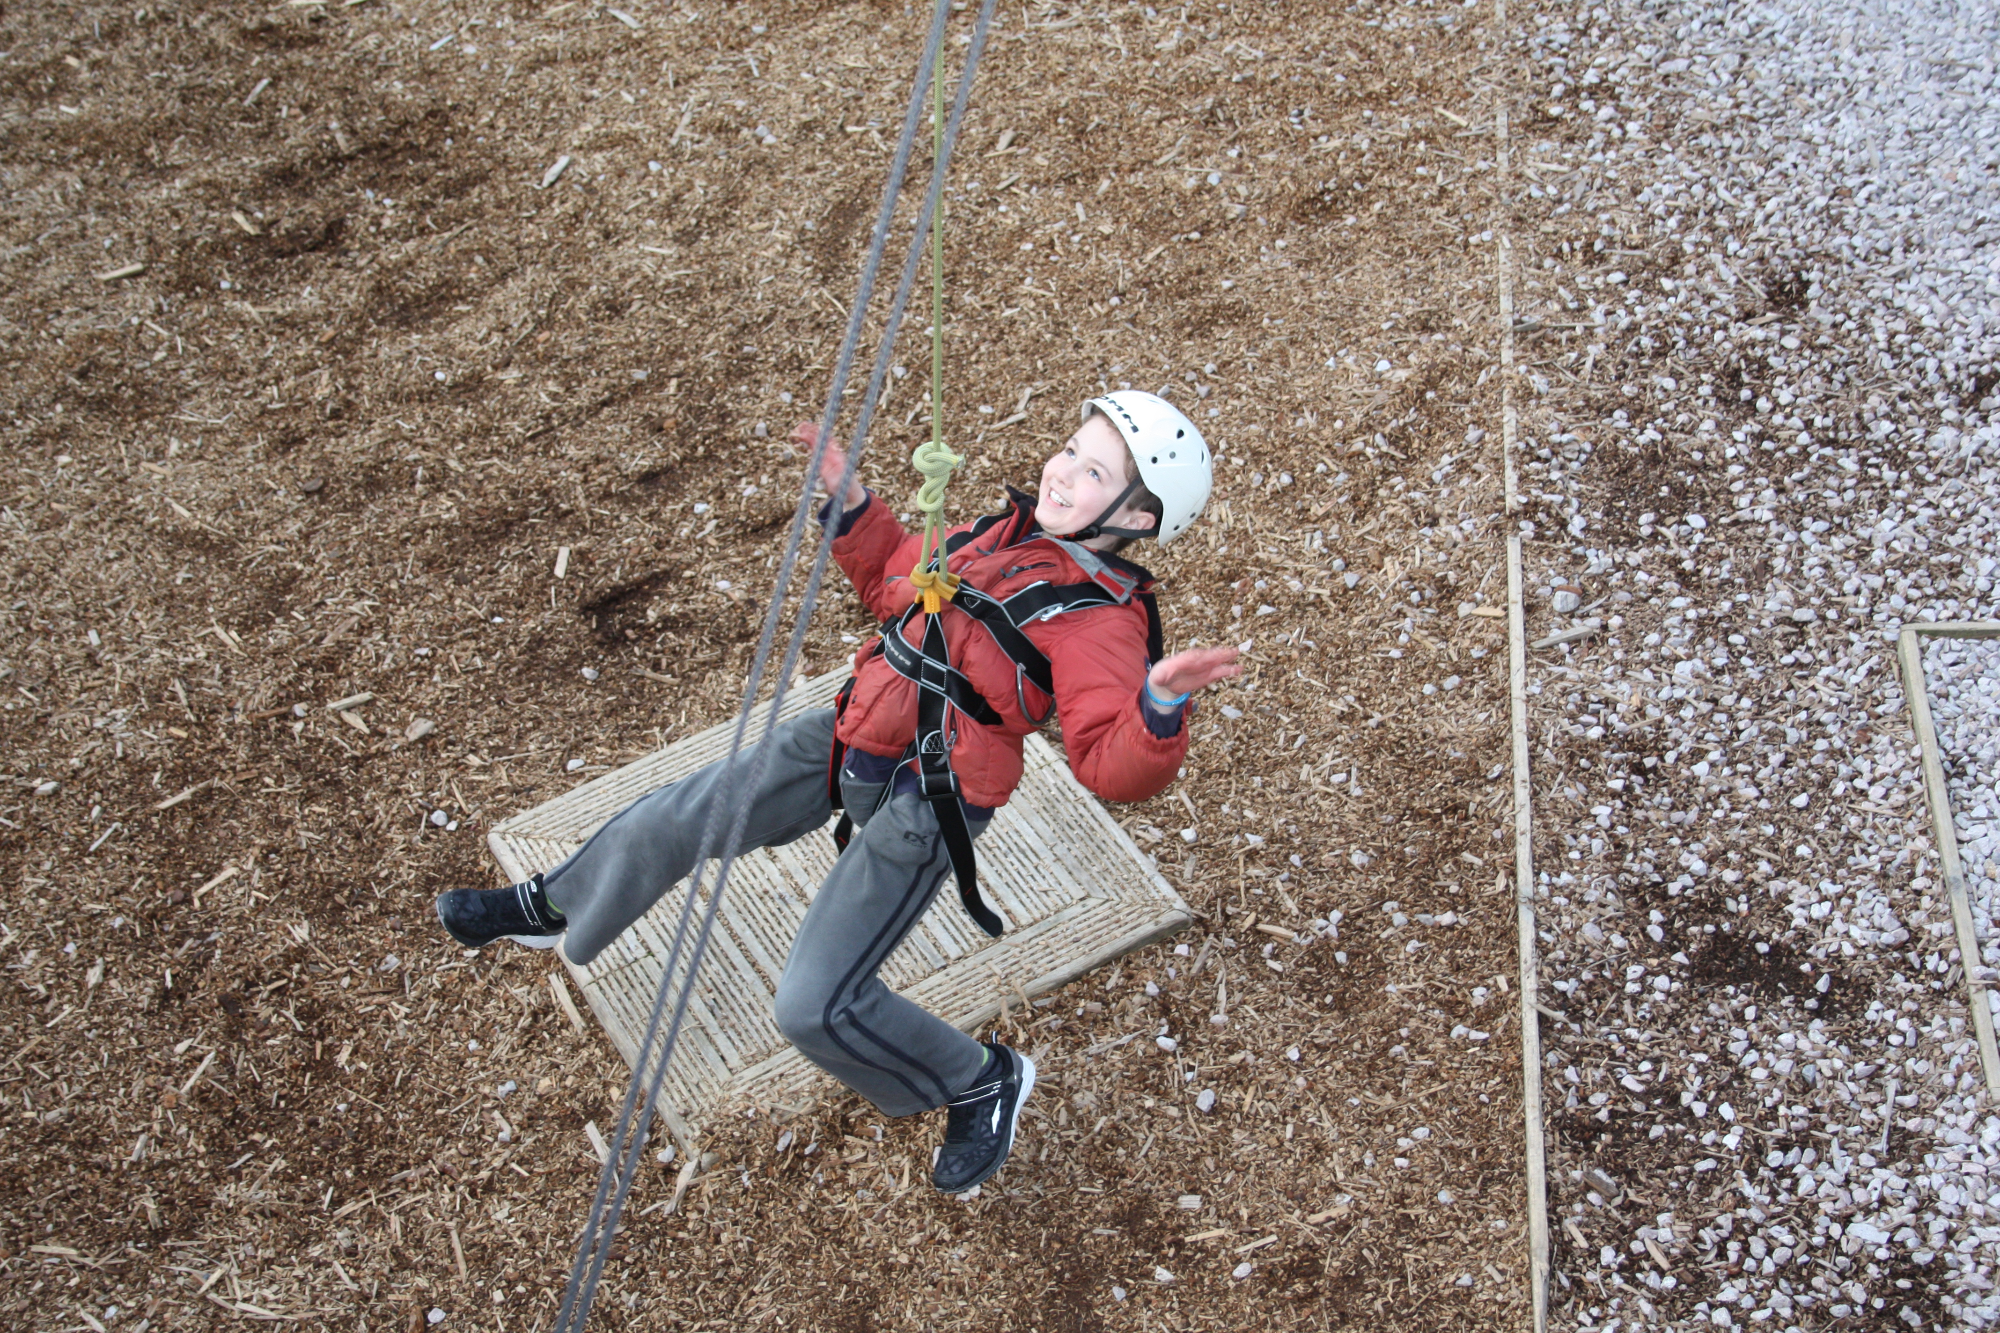
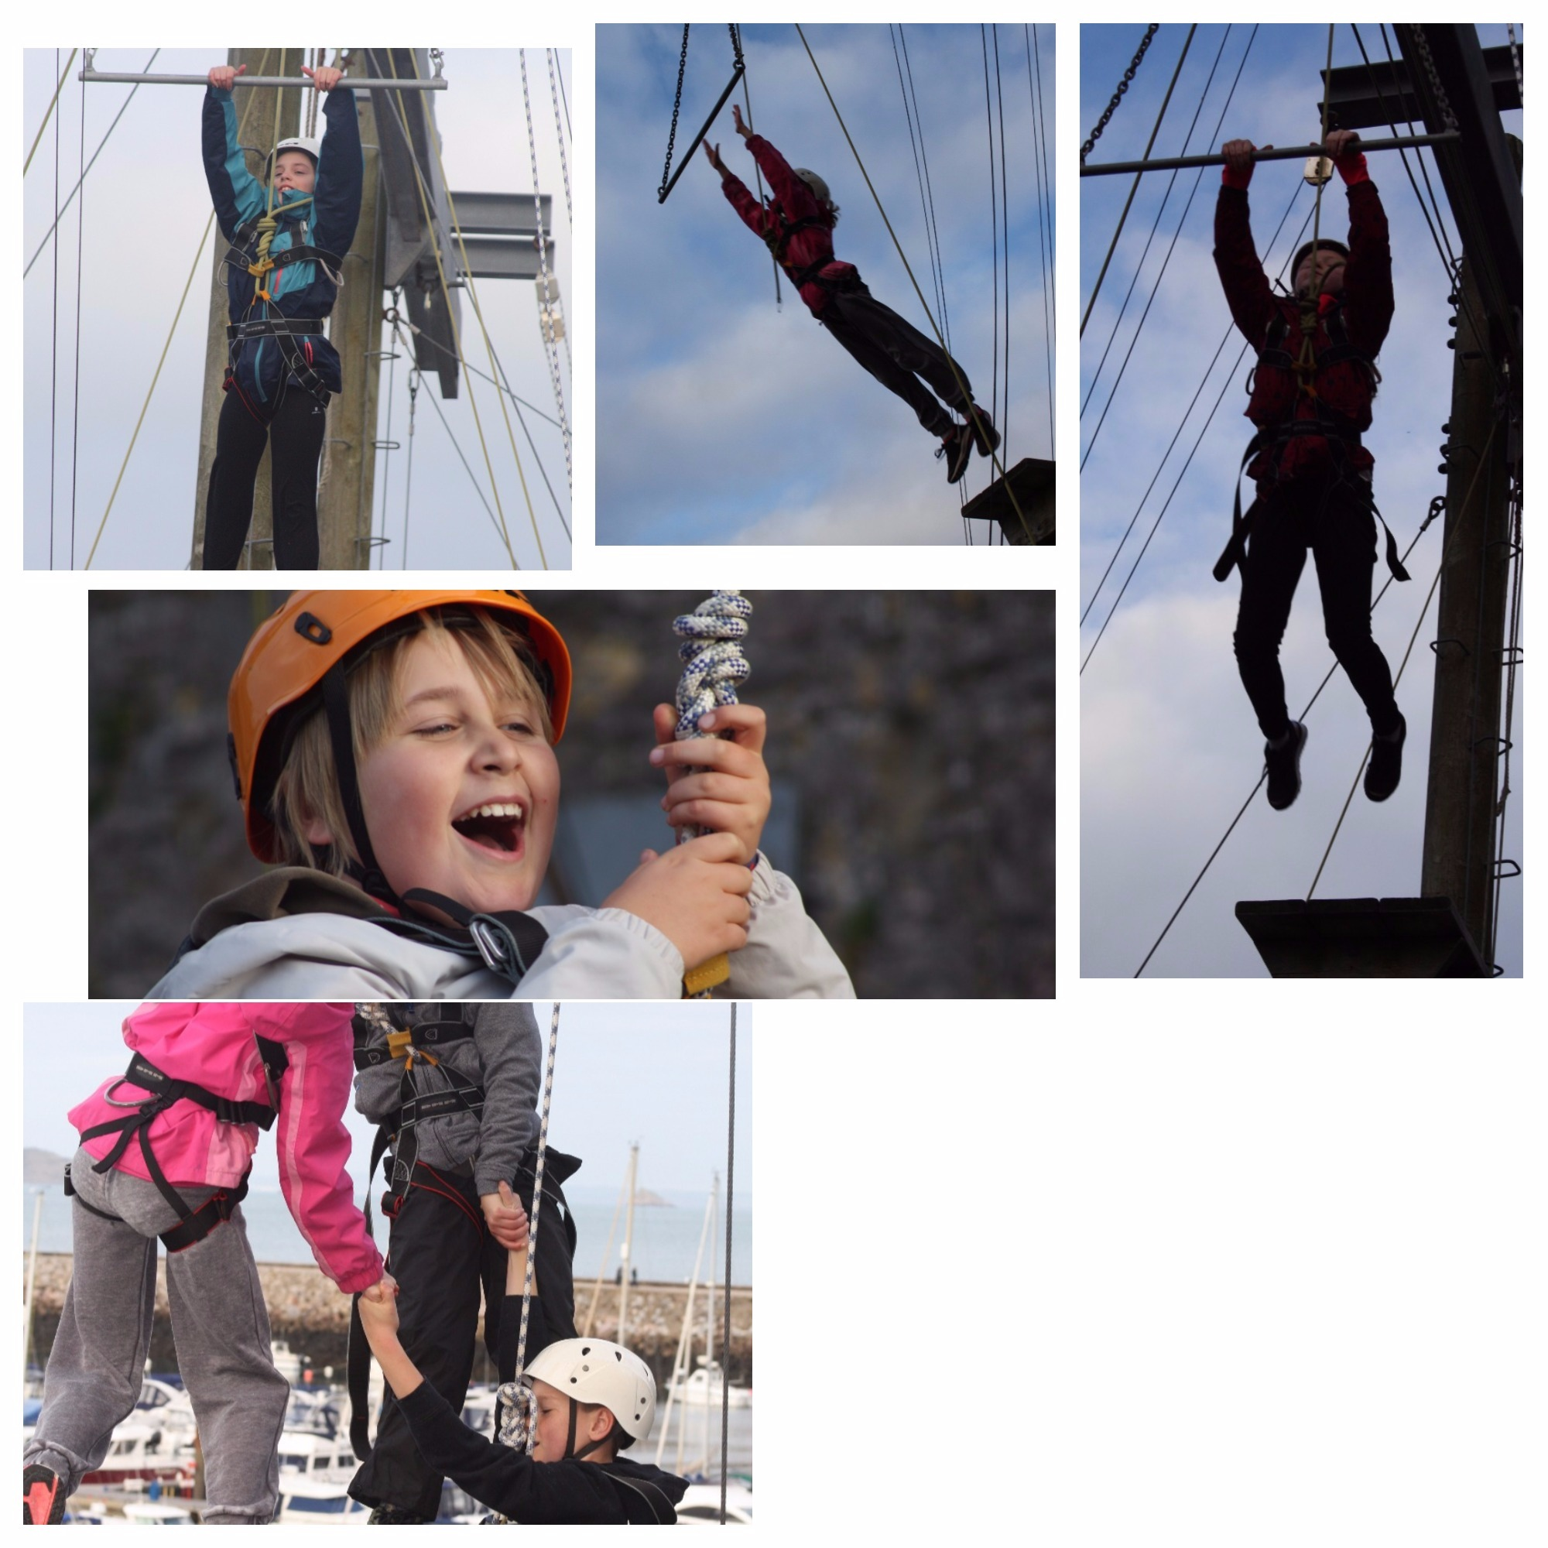
Day 3

Well, what an amazing day we have all had at Grenville! Mr Snow and Mrs Shaw’s group started the day with climbing in the old chapel. They began by traversing the wall using different colours, which ranged in difficulty. Following this was climbing up the walls to ring the bell at the top with all the children reaching the summit. After lunch, full of high spirits, they tackled the high ropes with great success – all of the children completed the leap of faith (jumping 10m of a very wobbly platform!)

Meanwhile, Mr Curnow’s group went canoeing and were lucky enough to do some seal spotting out on the mill-pond-like waters. They also saw schools of fish being driven into shore. Following this they enjoyed jumping in and out of the water and taking part in splashing competitions. In the afternoon they headed up to Berry Head to abseil in to the old quarry – again, all children showed great courage to step to edge and attempt the 90 foot drop. Mr Curnow was really proud of all of them!
