SUMMER TERM TOPIC – LEWIS CLASS
Subject | What we will be doing in school… | What you could do at home…
Theme | This term, our topic will have a geography focus, based on the country of the USA. The children will develop map reading skills, using the 8 compass points, to locate specific states, cities and physical features of the land. They will also explore land-use within the country, the effect of urbanisation on wildlife and the extreme weather of citizens of the USA. | Discuss with your child facts they are learning about the USA. Ask them to show you places they have learnt about online or on a map.  Research historical events to do with extreme weather that have happened recently and look at how this has changed the landscape of the specific place.
Reading | The children will continue to focus on the key skills needed for understanding any texts that we read: decoding, predicting, clarifying, questioning and summarising. | Encourage your child to read a wide variety of texts, which will expose them to a wider range of words.  This could involve texts related to research for our topic on the USA.
Writing  This Photo by Unknown Author is licensed under CC BY-NC | Firstly, the children will be learning and learning from the text ‘Ask Dr Fisher’, which is a series of creative letters, written in an agony-aunt style. The children will explore how the author uses humour to interest the reader and will then plan and write their own letters in the same style. | Encourage your child to practise their weekly spellings.
Maths | To start off, the children will be consolidating their learning about decimals, in particular calculating with decimals in different contexts, e.g. money. Following on from this, the children will be building on their prior-learning about time and statistics. | Continue to practise times tables and complete Mathletics activities.  Talk about problems in the context of money and purchasing items with your child.
Art  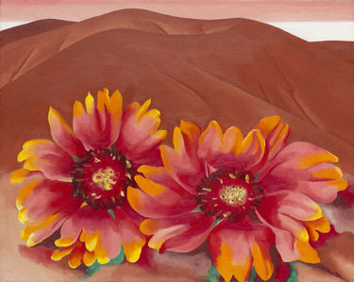 | The children will be studying a selection of artists from the USA, including Georgia O’Keefe. They will also learn about traditional North America art, from native American.
RE | This half term, the children will be deepening their understanding and beliefs around The Trinity. Additionally, they will explore the Christian traditions about baptism. | Talk to your children about any of the ‘I wonder…’ questions we will talk about at school. Don’t be afraid of not having an answer, but offer suggestions of answers that they could have.
PE  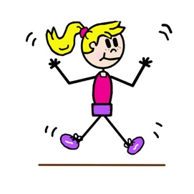 | The children will be completing a series of activities in a circuit. The activities will involve a variety of skills, including sprinting, balancing and jumping. The children will record their achievements and work on improving them each week.

