AUTUMN TERM TOPIC – CLASS 3
Subject | What we will be doing in school… | What you could do at home…
Theme  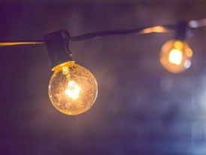 | Our overall theme this half-term is ‘Let Us Shine’. Linked to this, in science, the children’s learning will be focusing on light, its sources and how it travels. The children will also have the opportunity to take part in a shadow puppet workshop, where they will make their own puppets and use them to tell a story together. | Discuss with your child any natural or artificial light sources you may see or have in your home.  Support your child to research their own puppet character in the story before the day, to help them with creating their puppet.
Reading | This half term, we will continue to focus on the key skills needed for understanding any texts that we read: decoding, predicting, clarifying, questioning and summarising. | Encourage your child to read a wide variety of texts, which will expose them to a wider range of words.  Take time to discuss with your child what they have read and any clues the author gives to you about the characters or settings.
Writing  This Photo by Unknown Author is licensed under CC BY-NC | This half-term we will be continuing writing our own newspaper reports and also learn the story that we will perform during our puppet show. | Encourage your child to practise their weekly spellings. Can you spot the words in anything you are reading?  Do you know of any other journey tales?
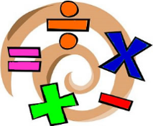  Maths | Firstly, we will be continuing our learning of the four operations, particularly the formal ways of recording solving them, e.g. column addition and subtraction. | Practise times tables as often as possible. This could be done orally or online as part of Mathletics. These are essential for children to know in order for them to progress into multiplying larger numbers in formal ways, e.g. multiplying a two digit number with a single digit number.
PE | This term, Class 3 are going to be working Miss Scoynes, from First Steps, who is a gymnastics coach in her spare time. Miss Scoynes will be teaching the children different skills and giving them opportunities to develop previously learnt skills.
Art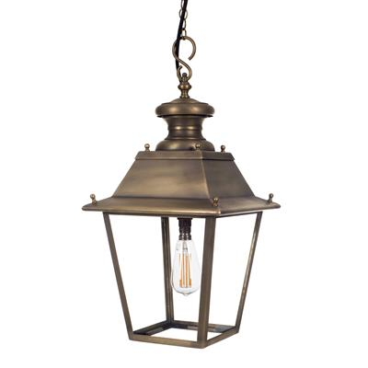 | Linked to our theme and the time of year, the children will be creating different types of lanterns, made from different materials, e.g. willow and recyclable materials.
RE | For the next two half-terms, the children will be learning about different inspirational people and the qualities that they made have. Then, the children will learn about how people of different faiths are inspired to live lives devoted to their God. | Talk to your children about any of the ‘I wonder…’ questions we will talk about at school. Don’t be afraid of not having an answer, but offer suggestions of answers that they could have.

