Welcome back to year 3 and 4!
I would like to start by welcoming you to a new academic year. What a fantastic first few weeks it has been and thank you for a lovely start to the year.
The children have had a great start and I am looking forward to getting to know them more and working with them this year. Like last year we have decided that the children should decide their class name. We held a vote and we have decided this year to call our class ‘The Jetsetters.’ This name was chosen to reflect our topic this term called ‘Sampford on Tour’.
Within this leaflet is an outline for the term, what we will be leaning about and general classroom arrangements.

Teaching

This year we are lucky to have a great team working in Years 3 and 4. Mrs Davey is training to be a teacher this year in our class. Mrs Dawson and Miss MacGregor will be working within the class supporting the children with their learning.

Sampford on Tour!
Geography and History   | This term the children will be learning about where other countries are in relation to Sampford Peverell. We will begin by exploring our local environment and then use maps and atlases to navigate our way around the world; the focus in Year 3 and 4 will be Europe. We are going to be naming and locating countries, researching different climates and exploring types of settlements and land use.  History will be linked to our school topic this term. We are going to be learning about the Vikings and focussing on the different journeys they made and the reasons why they settled in new countries.
How to help at home | Look at atlases together with your child and use compass directions to explain where countries are. Go on a local walk and draw a map to show the walk in greater detail – add a key. If you go on trips on weekends or over half term please gather some souvenirs for us to discuss in class, such as receipts or maps.
Literacy   | This term we are focusing on vocabulary choices, and sentence structures. We will be looking at a range of writing styles, linking these to our topic lessons throughout the term. We will also be focusing on speaking and listening skills to develop the children’s ability to communicate in a range of situations. Weekly guided reading sessions will also take place where we will focus on the comprehension of a text.
How to help at home | Spelling practice and a short amount of reading practice throughout the week would be greatly appreciated. Attached with this curriculum letter is a Year 3 and 4 spelling list. When your child practises their reading at home please discuss the text such as how the characters’ actions affect the story. Showing understanding of what they are reading is as important as becoming more fluent with their reading.
Maths   | There will be a strong emphasis on number in maths. We have started by understanding the place value of each digit in a number. Following this we will use that knowledge to help us add and subtract numbers with up to 4-digits. We will use the children’s times tables knowledge in our multiplication and division topics this term, building upon our understanding of how the two topics link. Each week we will have mental maths challenges which will include all four operations.
How to help at home | Having the ability to recall multiplication facts up to 12 x 12 quickly, is a skill that is expected of all KS2 children. Please help your child practice their times tables as well as exploring a variety of ways of learning them.
Science  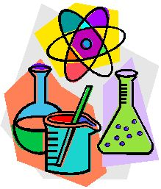 | Science will run alongside topic this term. We will be focussing on the digestive system, thinking about the journey that food makes around our body. We will start by understanding the importance of a balanced diet and how our digestive system benefits from this and how it benefits our health.
How to help at home | Whilst preparing family meals discuss the different food groups and their nutritional value. Research and discuss the function and characteristics of each organ during the process of digestion.
PE, RE, Music, DT and Languages  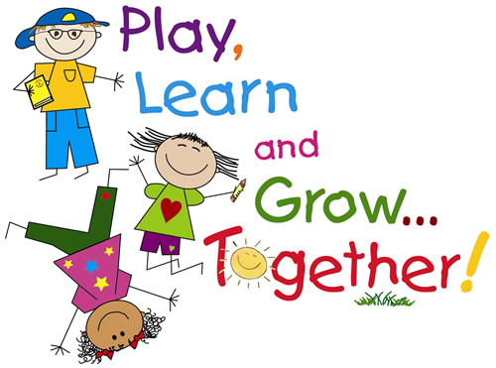 | We will have two PE sessions a week. These will be on a Monday and Thursday. Until half term we will be swimming on Thursdays. Please ensure that your child has the appropriate PE kit in school for these activities, preferably a blue/white t-shirt, shorts, tracksuit bottoms and trainers/plimsolls. We would recommend that PE kits stay in school during the week and go home on a Friday.  This term RE will enable children to think about who inspires them and to consider Jesus and Muhammad as inspirational figures for Christians and Muslims in the world today. In order to discover more about Jesus and Muhammad and their significance for Christians and Muslims the children will examine key passages from their respective holy books.  In Music we will be using the Taiko drums that are in school to create a piece of music that represents movement and a journey taking place. We will also be listening to traditional music from a range of European countries.  In DT we will focus on food technology where we will research and cook traditional European cuisine. We will also be creating 3D maps of European countries.  In our language lessons this term we will be focussing on Italian and French this term, engaging in conversations and developing accurate pronunciation and intonation. We will also be looking at the traditional names for the food we are cooking in DT.
How to help at home | Please practice the basic French and Italian greetings, can your children teach you what they are learning in school. We would encourage you to be as active as possible with your children, going for walks around your local area will link in to our Geography work too. Can you create patterns, rhymes and beats that your children could bring in to try on the Taiko drums.

