SPRING TERM TOPIC – THOROUGH THE KEYHOLE – a study in time
Subject | What we will be doing in school… | What you could do at home…
History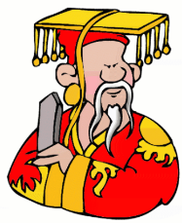 | We are looking at Ancient China and in particular the Shang Dynasty – which is thought to be the first large civilisation in China. | Use the internet to discover areas of the Shang Dynasty in more depth – encourage children to ask questions and then consider how they might answer them. They could draw pictures, illustration, calligraphy or models – showing what it was like during that period.
English | We will be linking our writing to China by writing Non-Chronological Reports. We will begin by focussing on dragons, then their own chosen topic and finish up with an area of the Shang Dynasty which interests them. | Children will be set homework to find out about an area which they find interesting; it can be anything but be aware of mistaking NC Reports with biographies. They can bring in facts, pictures, artefacts etc to support and guide their writing in class.  When reading, see if you can find some non-fiction books to read.
Maths  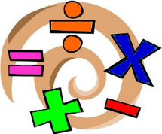 | Fractions, decimals and percentages are the main focus of this term. Looking at how to link them together. | This term I will be sending home their arithmetic practice papers which focus on the use of number; it would be great if children could work on areas they need to develop. Also, any real-life application linked to fractions would be great – measuring, money problems including calculating change and time problems too.
Computing | The children will be using Microsoft PowerPoint to create an area of their Non-Chronological report. | They can use any slide show application to help present their ideas and homework. Talk about how to open and save information.  February also includes SID (Safer Internet Day) when we will look at how to stay safe online. Think about your electronic devices at home – how do we stay safe or keep our information safe?
PE | In PE we will be looking at extending our invasion game knowledge to learn the rules of Tag Rugby as well as looking at learning some Tai Chi! | See if you can learn some of these moves at home! Get a ball and practise throwing and catching in the garden and maybe watch some rugby on the telly!

Art | In art the children will be looking at using different material and techniques to imitate the Shang Dynasty bronze vessel designs. | Look at different vessels (cups, mugs, jugs, vases etc.) and how they are designed. Look at the shape, size, features and designs.
Music  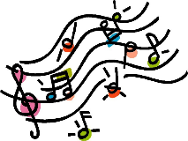 | In music we will be learning to play the glockenspiel looking at playing and creating music linked to China. | Listen to a range of music. What does music sound like around the world?
MFL | We will be attempting to learn a little bit of Mandarin – continuing our links to China! | Learn some Mandarin together! There are some great free websites and Apps where you can begin to learn Mandarin. Ask them about the words they have learnt and then try to use them at home.
RE | This term the children will be looking at the ‘Kingdom of God’. Looking at BIG questions such as ‘What kind of King is Jesus?’; ‘How does Jesus compare to other Kings?’; and ‘What does the bible tell us about what the kingdom of God is like?’ | Look at asking and answering these BIG questions at home. Do you have any BIG questions of your own? Bring them into school with your thoughts.
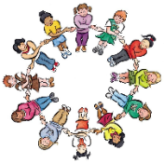  PSHE | Our whole school focus is our Christian Values of: Teamwork, Honesty, Forgiveness, Respect, Trust and Faith so our PSHE sessions will link to these. | Talk about how we can show all of these values in aspects of our lives. Link positive actions to these – ‘You showed great respect towards…today’ or ‘It’s great that I can trust you to do the right thing’ or ‘

