Grenville House Residential
Day 1

After an uneventful coach journey (just the way I like them) we all arrived safely at Grenville and kicked off with a tour of the site – including their brand-new changing rooms.

We split into our groups with one group going off to enjoy raft building with Mr Curnow and the other two tackling the tricky problem solving exercises in the yard.

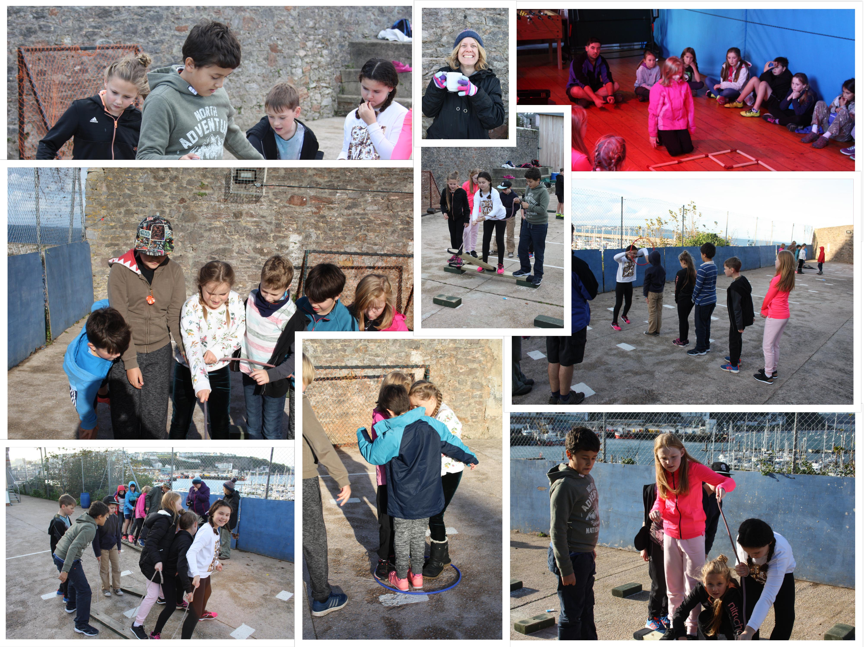
All the children had a great time jumping off their rafts and working together to get them back on – with hilarious results.

Grenville House Residential
Day 2

It was an action-packed day today with Mr Curnow’s group going up onto Berry Head to orienteer around the In the afternoon they used the indoor climbing walls to traverse, belay and scale each wall. It was super to see the children spotting each other and encouraging people to reach for the highest!
Mr Snow and Mrs Shaw’s groups had the excitement and trepidation of going caving! All the children were brilliant and squeezed and squired they way through the underground caverns and cracks. Then, in the afternoon, it was their turn to orientate themselves around Berry Head.

