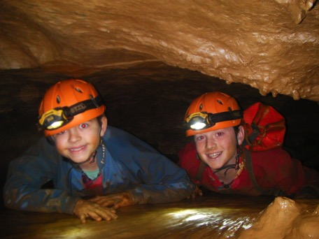
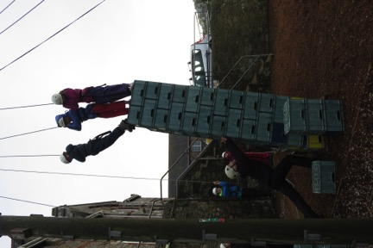
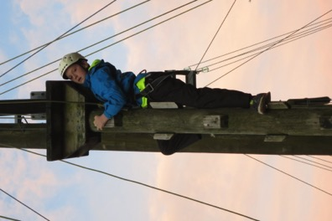

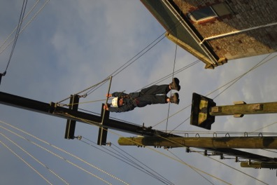
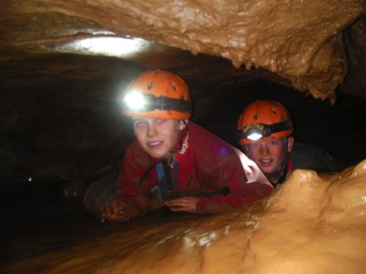
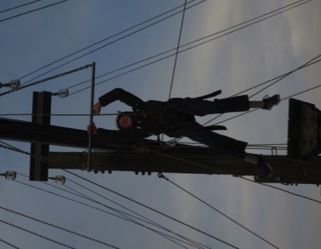

Day 4

Our final full day at Grenville was an excitable one. Mr Curnow’s group were massively looking forward to taking on the caving – after the positive feedback from the other group earlier on in the week. All of the children (and Mr Curnow) completed all of the optional challenges – including the ‘cheese grater’! In the afternoon, it was their turn to climb the high ropes and complete all of the challenges in front of them.

The other group had to have their day switched over as the weather prevented them from abseiling as the wind was too high. This meant that canoeing was switched to the morning; we were trusted to paddle against the wind – with mixed results!! After much paddling, we made it into the harbour and had a great time jumping into the water and playing ‘battleships’. Unfortunately there is no photographic evidence as Mr Snow managed to conduct a scientific experiment to see if his camera floated whilst clambering back into the canoe – it didn’t! Luckily he didn’t drop the camera during the abseiling session in the afternoon. The weather had cleared to reveal great conditions for descending the rocks. All of the children did themselves proud with all of them sitting on the edge after harnessing up.

We are looking forward to completing our last activity tomorrow and coming home to see our wonderful families!

